GIT HUB:

Git log:

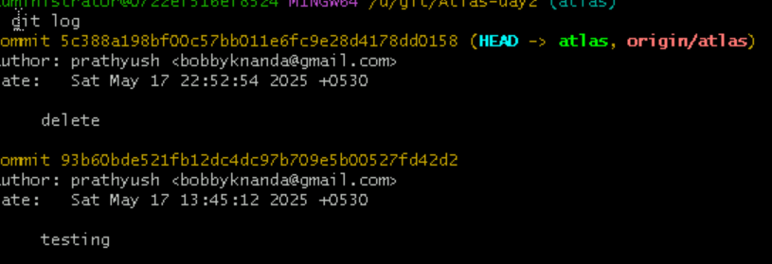

Git show:

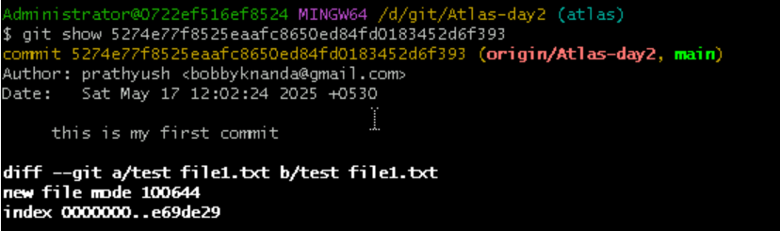

Git branch:



Create new branch:

Git branch <branch-name>

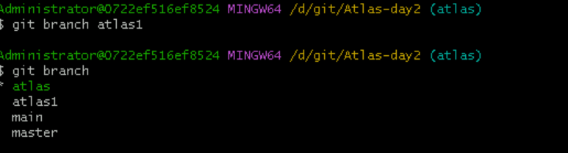

**Switching from brach to another branch:**

git checkout master



Merging branches:

Git merge

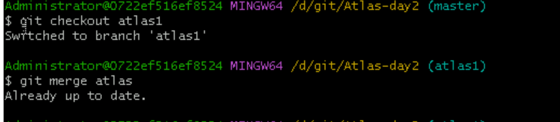

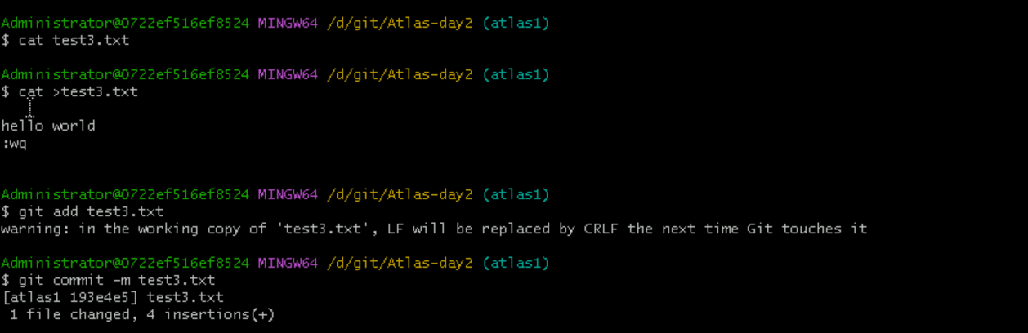

Revert:

Git revert 40 digit log code



